 | Abdi İpekçi Caddesi Kaşıkçıoğlu Apt. No:42 D:2 34365 Nişantaşı İstanbul  www.artxist.com  info@artxist.com  T. +90 212 291 77 84 F. +90 212 343 69 35 | Press Release

Engin Konuklu’s solo show titled Éternité is taking place at x-ist between 11 September 2014 and 11 October 2014.

ENGİN KONUKLU | Éternité

We had seen Engin Konuklu’s works; an artist born in 1990 in İzmir, for the first time last year at x-ist, in the exhibition titled Intersection V. Using nostalgic imagery for his Éternité exhibition, Konuklu examines the relationship between the viewer and the person being photographed in 19th century post mortem photographs.

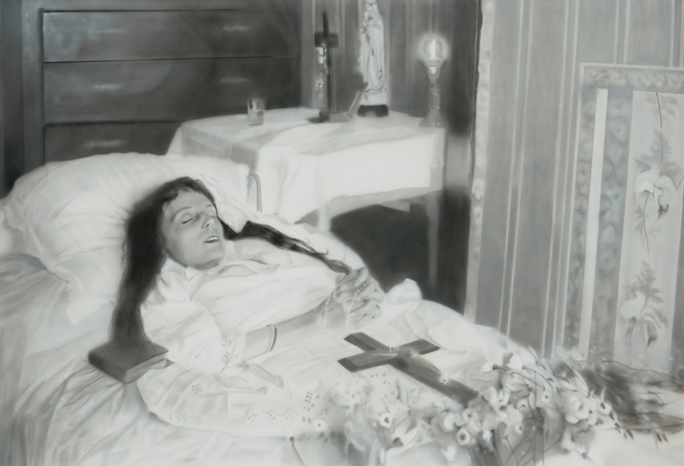
Engin Konuklu, “Éternité”, 170x250 cm, Acrylic on Canvas, 2014

“…In front of the lens, I am at the same time: the one I think I am, the one I want others to think I am, the one the photographer thinks I am, and the one he makes use of to exhibit his art(…) The photograph represents that very subtle moment when, to tell the truth, I am neither subject nor object but a subject who feels he is becoming an object: I then experience a micro-version of death: truly becoming a specter..”
Roland Barthes, Camera Lucida: Reflections on Photography

Post mortem photography which was mainly adapted as a grieving ritual in Europe and America in 19th century actually dates further back. The tradition of drawing dead priests in 15th century gained popularity with photography. Due to long exposure times needed in first cameras, dead members of the family appeared clearly in the photographs while other members were blurry. Techniques such as “hidden mother” were established in order to maintain the blurry effect. For the photographs to be focused on the children, mothers are hidden under linens (with their silhouettes still visible) helping their kids in maintaining a stable position. Many new rituals were formed regarding life and death with the invention of photography in the 19th century. Engin Konuklu expresses his views on death in the following manner:

“Death might bring gloom or joy to those who are left behind; according to Meursault it resembles emptiness and it means farewell in post mortem photographs. But what is death for the dead? It could mean reaching a state of heaven or hell to Christians and Muslims while it would not be of much concern for a Hindu born in an upper cast or one who is bound to be a priest .The word that defines best the idea of death to me is “éternité”. This word also embodies the idea of eternity while symbolizing a state with nothing post or prior to it as a French philosophy term. Death has the power to worry, intrigue but also disturb human beings. What inspired me to create a series focusing on death is “éternité”.; which is also the title of the first work in the series. In the photo where a young French girl is in bed wearing her best clothes, in a room covered by religious symbols and wallpaper, the figure resembles someone who is sleeping rather than dead..”

For further information contact Ece Göymen from x-ist.
ece@artxist.com
M. 537 349 13 27
T. 212 291 77 84

ENGİN KONUKLU | Adana, 1990

After graduating from Dokuz Eylül University Fine Arts Faculty Painting Department in 2011, Konuklu continues his masters degree in the Painting Department of the same university. The artist opened his first solo show “Undefined” at the American Hospital Art Gallery “Operation Room” in 2011. Among the other exhibitions Konuklu attended are “30th Contemporary Artists Istanbul Exhibition” (Akbank Art Gallery, Istanbul, 2011), “Situations Possibilities” (İzmir, 2011), “Look Inside II” (İzmir, 2011), “Painting and Sculpture Museums Association, 30th Anniversary Exhibition” (Istanbul, 2011) and Contemporary Istanbul’13 art fair.

